Lessons learnt
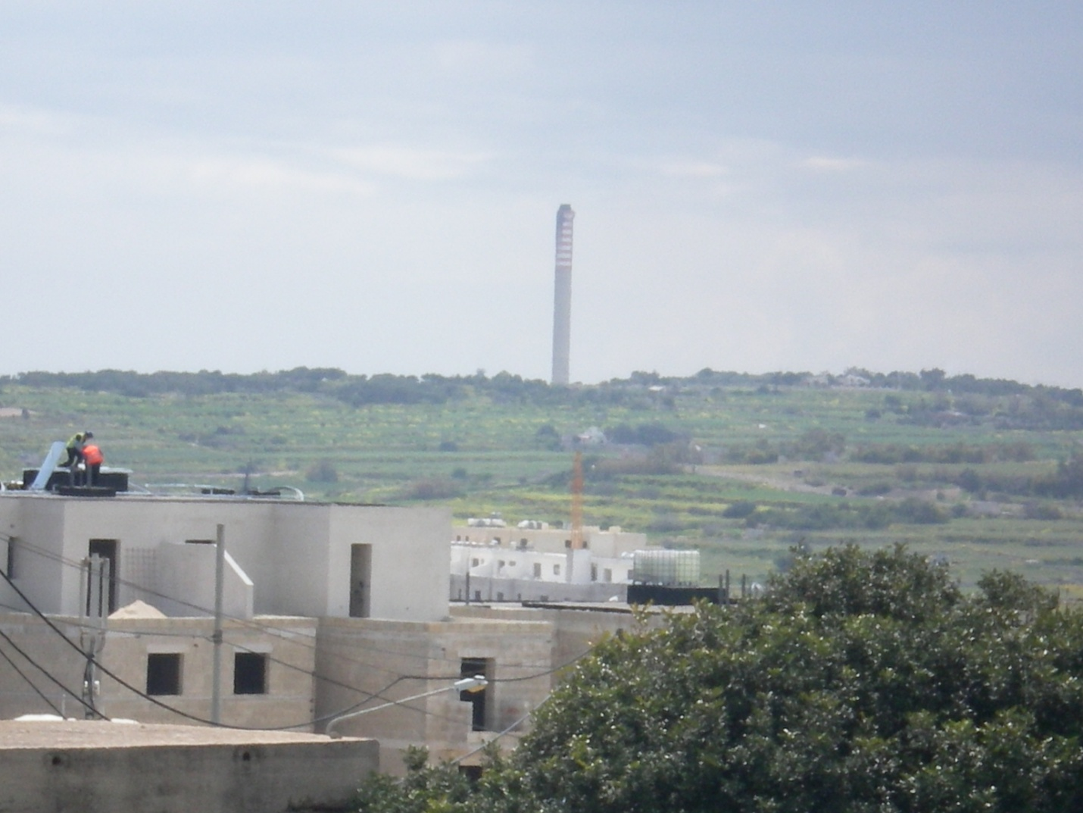Electricity can be produced in various ways by solar, wind, wave, or fossil fuels. In Malta most of the electricity generated is obtained from fossil fuels. When a power station is old it can produce more toxic wastes, so the need for a new power plant becomes urgent. The government realised that the old power station of Marsa must be closed down and an extension built at the Delimara plant. Heavy fuel oil is the type of fuel that this extension will be using. This heavy fuel oil will produce 31 tons of toxic waste every day and 2 million Euro to transport the hazardous waste out of Malta.
The EU is stating that member states must lessen their carbon foot print, so a better solution would have been to use natural gas. Natural gas is better for the environment even though it is a type of fossil fuel.
I really cannot understand why the government opted for the use of heavy fuel oil when at school, through geography and physics, we learn a lot about alternative forms of energy and that natural gas is the fossil fuel which has the least negative impact on the environment?

